Labor Bulletin

Center for Regional Economics and Politics (CEPR)

O’Higgins Region JJA-2020

06/10/2021

#### Number of workers per trimester

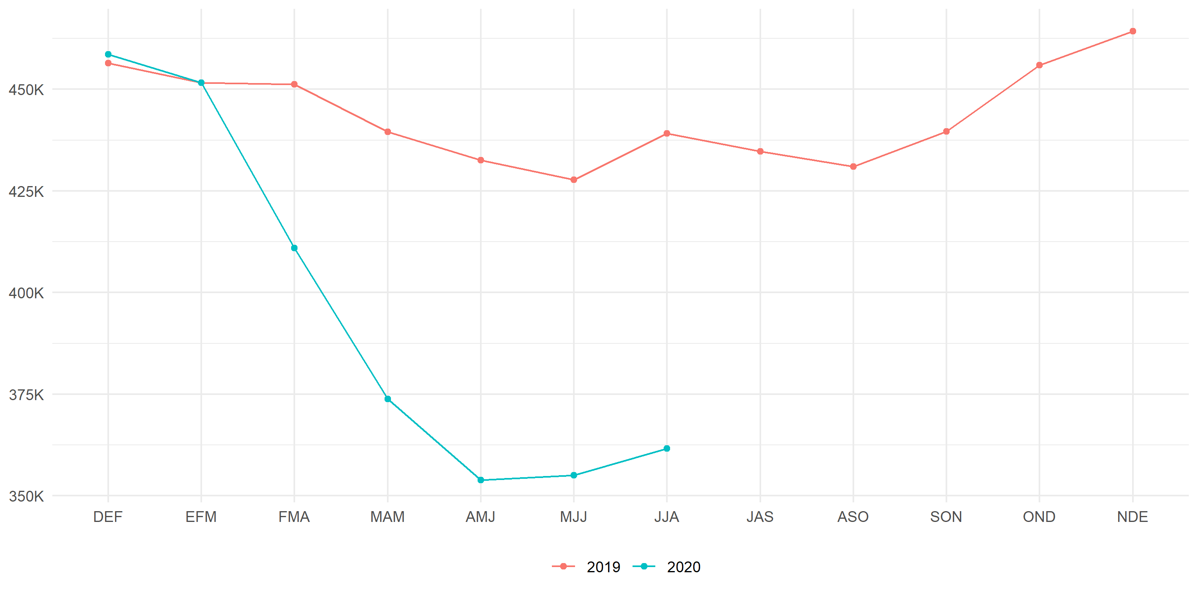

Aquí va texto:

* Texto n°1.
* Texto n°2.

#### Labormarket descomposition

|  | **Employed** | | **Unemployed** | | **Inactive** | |
| --- | --- | --- | --- | --- | --- | --- |
| **Age** | **JJA-2019** | **JJA-2020** | **JJA-2019** | **JJA-2020** | **JJA-2019** | **JJA-2020** |
| **15 - 29** | 85,894 | 61,167 | 16,984 | 16,988 | 101,222 | 117,504 |
| **30 - 44** | 152,890 | 138,444 | 14,209 | 19,175 | 37,139 | 58,095 |
| **45 - 59** | 149,353 | 124,458 | 7,048 | 13,429 | 49,935 | 67,595 |
| **60 or more** | 50,982 | 37,539 | 769 | 3,663 | 118,259 | 138,853 |
| **Overall** | 439,119 | 361,608 | 39,010 | 53,255 | 306,555 | 382,048 |